Simple:

**1)Number of people employed**

==>select c.family_id, c.name,c.aadhar_no from citizen as c , employee as e where c.aadhar_no = e.aadhar_no order by c.family_id;

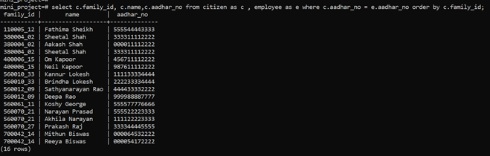

**2)Assets each family can access**

==>select c.aadhar_no, c.name, a.reg_no, a.type from citizen as c, assets as a

        where c.aadhar_no = a.asset_holder;

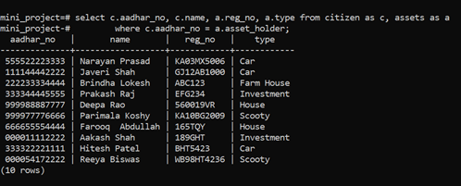

**3)Number of vaccination centers in Bangalore**

==>select building_no,pincode from amenities where city='Bengaluru' and type='Vaccination Center' order by pincode;

==>select count(*) from amenities where city='Bengaluru' and type='Vaccination Center';

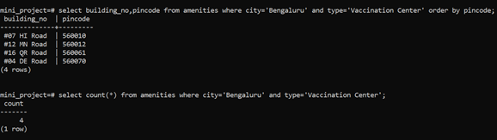

Nested:

**1)Literacy rate:**

==>select cast((select count(c.aadhar_no) from citizen as c where c.aadhar_no in

(select e.aadhar_no from education as e) and c.age>7) as float) /

cast( (select count(*) from citizen) as float)*100;

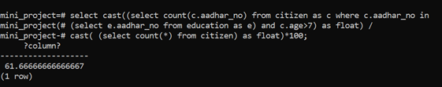

**2)Birth rate:**

==>select  cast((select count(c.aadhar_no) from citizen as c where date_of_birth between '2021-01-01' and '2021-12-31') as float) /

cast( (select count(*) from citizen) as float)*100;

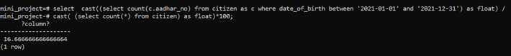

**3)Gender ratio:**

select  cast((select count(c.aadhar_no) from citizen as c where gender='Female') as float) /

cast((select count(c.aadhar_no) from citizen as c where gender='Male') as float);

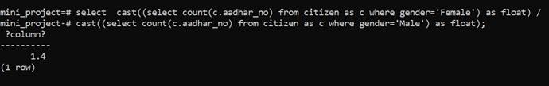

**4)Death rate:**

==>select  cast((select count(*) from death as d where d.date between '2021-01-01' and CURRENT_DATE) as float)/

cast( (select count(*) from citizen) as float)*100 ;

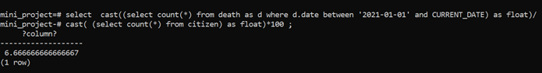

**5)List of unemployed people who are educated**

===> select * from citizen as c where c.aadhar_no in(select e.aadhar_no from education as e) and c.aadhar_no not in(select emp.aadhar_no from employee as emp);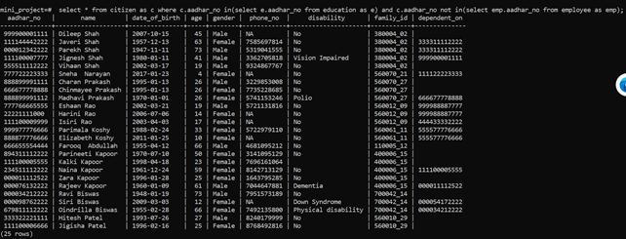

==> select * from citizen as c where c.aadhar_no in(select e.aadhar_no from education as e) and c.aadhar_no not in(select emp.aadhar_no from employee as emp) and age between 18 and 65;

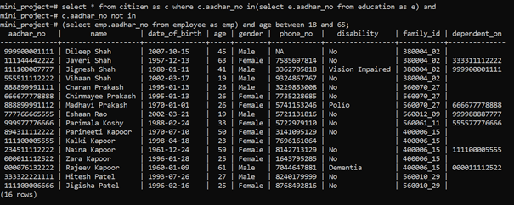

**6)Details of citizen who are working in the companies under the IT industry**

===>select * from citizen where aadhar_no in

(select aadhar_no from employee where company_name in

(select company_name from employer  where 'IT' = ANY(industry)));

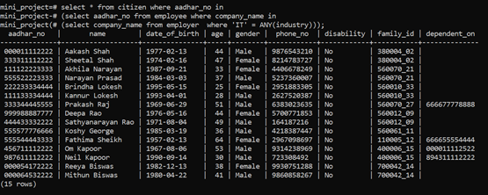

**7)Details (including employment details) of people who died who worked in the area 'Manyata Tech Park' due to covid-19.**

===> select * from citizen as c natural join employee as e where c.aadhar_no=e.aadhar_no and

c.aadhar_no in (select aadhar_no from death where cause = 'Covid-19') and company_name in

(select name from employer  where address like 'Manyata Tech Park%');

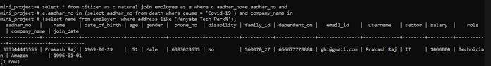

Group by having:

**1)Families having more than 2 disabled people**

==>select family_id, count(disability) from citizen where disability not like 'No' group by family_id having count(disability)>2 or count(disability)=2;

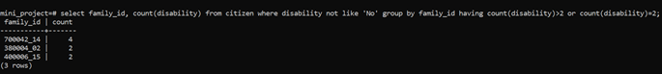

**2)State Wise Population of states having at least more than 5 people.**

==>select f.state, count(c.aadhar_no) from citizen as c , family as f where c.family_id=f.family_id group by f.state having count(c.aadhar_no)>5 or count(c.aadhar_no)=5;

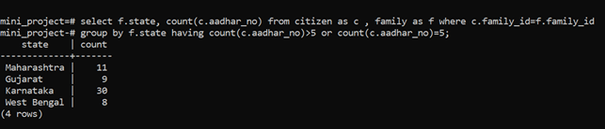

View:

**1)Family income of each family - create view**

==>create view family_income as (select c.family_id,sum(e.salary) as income from employee as e ,citizen as c where e.aadhar_no= c.aadhar_no group by c.family_id);

